Case Study Report



**Tech Saksham**

Data Analytics with Power BI

**“Real-Time Analysis of Bank Customers”**

**“Government Arts And Science College, Aundipatti”**

|  |  |
| --- | --- |
| **NM ID** | **NAME** |
| **0AEDED50B155AF3922D44DE4DF9341D8** | **BALAKRISHNAVENI.P** |

|  |  |
| --- | --- |
|  |  |
|  | Trainer Name: R.UMAMAHESHWARI |
|  | Master Trainer: R.UMAMAHESHWARI |

**ABSTRACT**

In the digital age, data has become an invaluable asset for businesses, particularly in the banking sector. The proposed project, “Real-Time Analysis of Bank Customers,” aims to leverage PowerBI, a leading business intelligence tool, to analyze and visualize real-time customer data. This project will enable banks to gain deep insights into customer behavior, preferences, and trends, thereby facilitating data-driven decision-making and enhancing customer satisfaction. The real-time analysis will allow banks to respond promptly to changes in customer behavior or preferences, identify opportunities for cross-selling and up-selling, and tailor their products and services to meet customer needs. The project will also contribute to the broader goal of digital transformation in the banking sector, promoting efficiency, innovation, and customer-centricity.

**INDEX**

|  |  |  |
| --- | --- | --- |
| **Sr. No.** | **Table of Contents** | **Page No.** |
| 1 | Chapter 1: Introduction | 4 |
| 2 | Chapter 2: Services and Tools Required | 6 |
| 3 | Chapter 3: Project Architecture | 7 |
| 4 | Chapter 4: Modeling and Result | 9 |
| 5 | Conclusion | 18 |
| 6 | Future Scope | 19 |
| 7 | References | 20 |
| 8 | Links | 21 |

**CHAPTER 1**

**INTRODUCTION**

* 1. **Problem Statement**

In today’s competitive banking landscape, understanding customer behavior and preferences is crucial for customer retention and revenue generation. However, banks often face challenges in analyzing customer data due to the sheer volume and velocity of data generated. Traditional data analysis methods are time-consuming and often fail to provide real-time insights. This lack of real-time analysis can lead to missed opportunities for customer engagement, cross-selling, and up-selling, impacting the bank’s revenue generation and customer satisfaction. Furthermore, the complexity and diversity of customer data, which includes transaction history, customer feedback, and demographic data, pose additional challenges for data analysis.

* 1. **Proposed Solution**

The proposed solution is to develop a PowerBI dashboard that can analyze and visualize real-time customer data. The dashboard will integrate data from various sources such as transaction history, customer feedback, and demographic data. It will provide a comprehensive view of customer behavior, preferences, and trends, enabling banks to make informed decisions. The dashboard will be interactive, user-friendly, and customizable, allowing banks to tailor it to their specific needs. The real-time analysis capability of the dashboard will enable banks to respond promptly to changes in customer behavior or preferences, identify opportunities for cross-selling and up-selling, and tailor their products and services to meet customer needs.

* 1. **Feature**
* **Real-Time Analysis**: The dashboard will provide real-time analysis of customer data.
* **Customer Segmentation**: It will segment customers based on various parameters like age, income, transaction behavior, etc.
* **Trend Analysis**: The dashboard will identify and display trends in customer behavior.
* **Predictive Analysis**: It will use historical data to predict future customer behavior.
  1. **Advantages**
* **Data-Driven Decisions**: Banks can make informed decisions based on real-time data analysis.
* **Improved Customer Engagement**: Understanding customer behavior and trends can help banks engage with their customers more effectively.
* **Increased Revenue**: By identifying opportunities for cross-selling and up-selling, banks can increase their revenue.
  1. **Scope**

The scope of this project extends to all banking institutions that aim to leverage data for decision-making and customer engagement. The project can be further extended to incorporate more data sources and advanced analytics techniques, such as machine learning and artificial intelligence, to provide more sophisticated insights into customer behavior. The project also has the potential to be adapted for other sectors, such as retail, healthcare, and telecommunications, where understanding customer behavior is crucial. Furthermore, the project contributes to the broader goal of digital transformation in the banking sector, promoting efficiency, innovation, and customer-centricity.

**CHAPTER 2**

**SERVICES AND TOOLS REQUIRED**

**2.1 Tools and Software used**

**Tools**:

* **PowerBI**: The main tool for this project is PowerBI, which will be used to create interactive dashboards for real-time data visualization.
* **Power Query**: This is a data connection technology that enables you to discover, connect, combine, and refine data across a wide variety of sources.

**Software Requirements**:

* **PowerBI Desktop**: This is a Windows application that you can use to create reports and publish them to PowerBI.
* **PowerBI Service**: This is an online SaaS (Software as a Service) service that you use to publish reports, create new dashboards, and share insights.
* **PowerBI Mobile**: This is a mobile application that you can use to access your reports and dashboards on the go.

**CHAPTER 3**

**PROJECT ARCHITECTURE**

**3.1 Architecture**

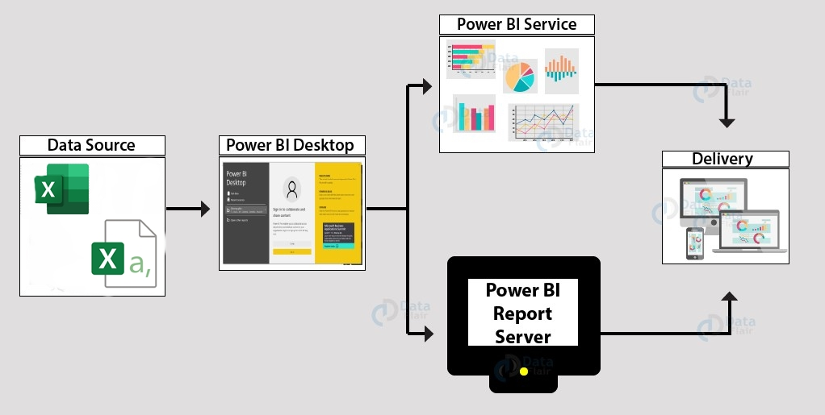

Here’s a high-level architecture for the project:

1. **Data Collection**: Real-time customer data is collected from various sources like bank transactions, customer interactions, etc. This could be achieved using services like Azure Event Hubs or AWS Kinesis.
2. **Data Storage**: The collected data is stored in a database for processing. Azure SQL Database or AWS RDS can be used for this purpose.
3. **Data Processing**: The stored data is processed in real-time using services like Azure Stream Analytics or AWS Kinesis Data Analytics.
4. **Machine Learning**: Predictive models are built based on processed data using Azure Machine Learning or AWS SageMaker. These models can help in predicting customer behavior, detecting fraud, etc.
5. **Data Visualization**: The processed data and the results from the predictive models are visualized in real-time using PowerBI. PowerBI allows you to create interactive dashboards that can provide valuable insights into the data.
6. **Data Access**: The dashboards created in PowerBI can be accessed through PowerBI Desktop, PowerBI Service (online), and PowerBI Mobile.

This architecture provides a comprehensive solution for real-time analysis of bank customers. However, it’s important to note that the specific architecture may vary depending on the bank’s existing infrastructure, specific requirements, and budget. It’s also important to ensure that all tools and services comply with relevant data privacy and security regulations.

**CHAPTER 4**

**MODELING AND RESULT**

**VISUALISATION:**

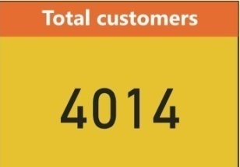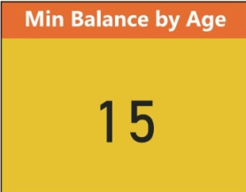

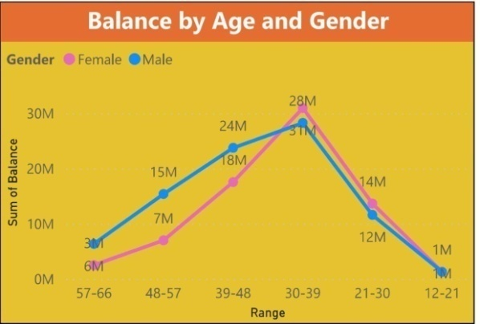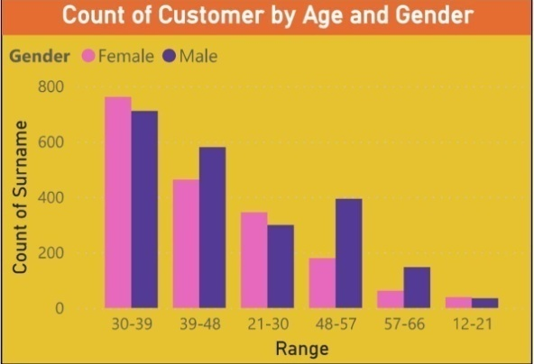 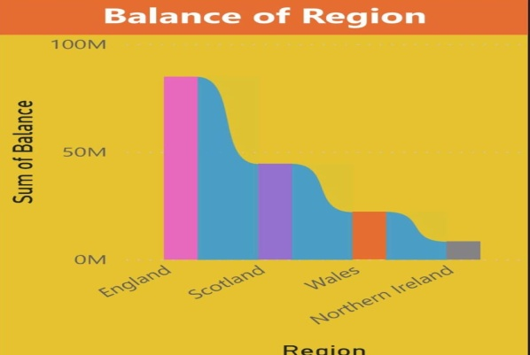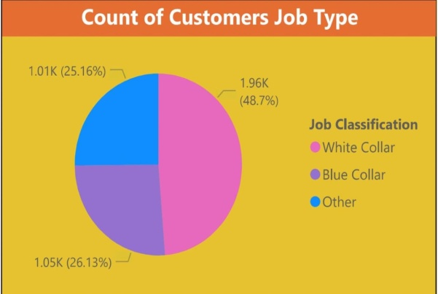**:**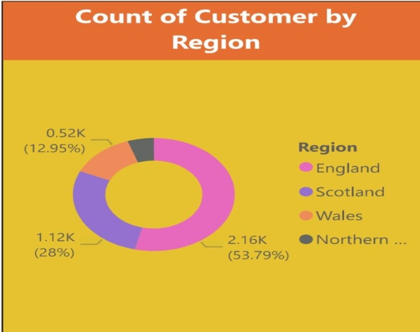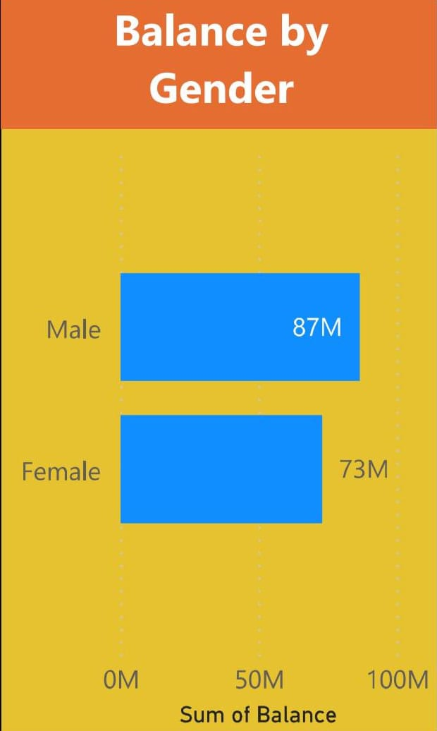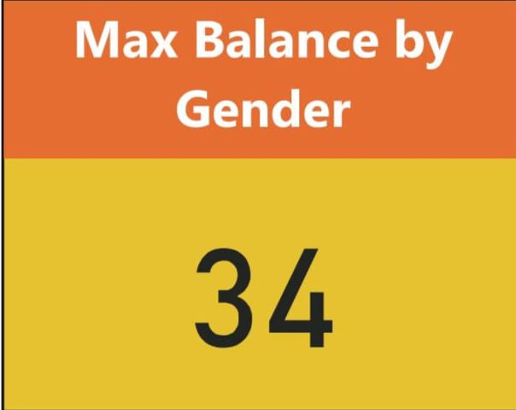

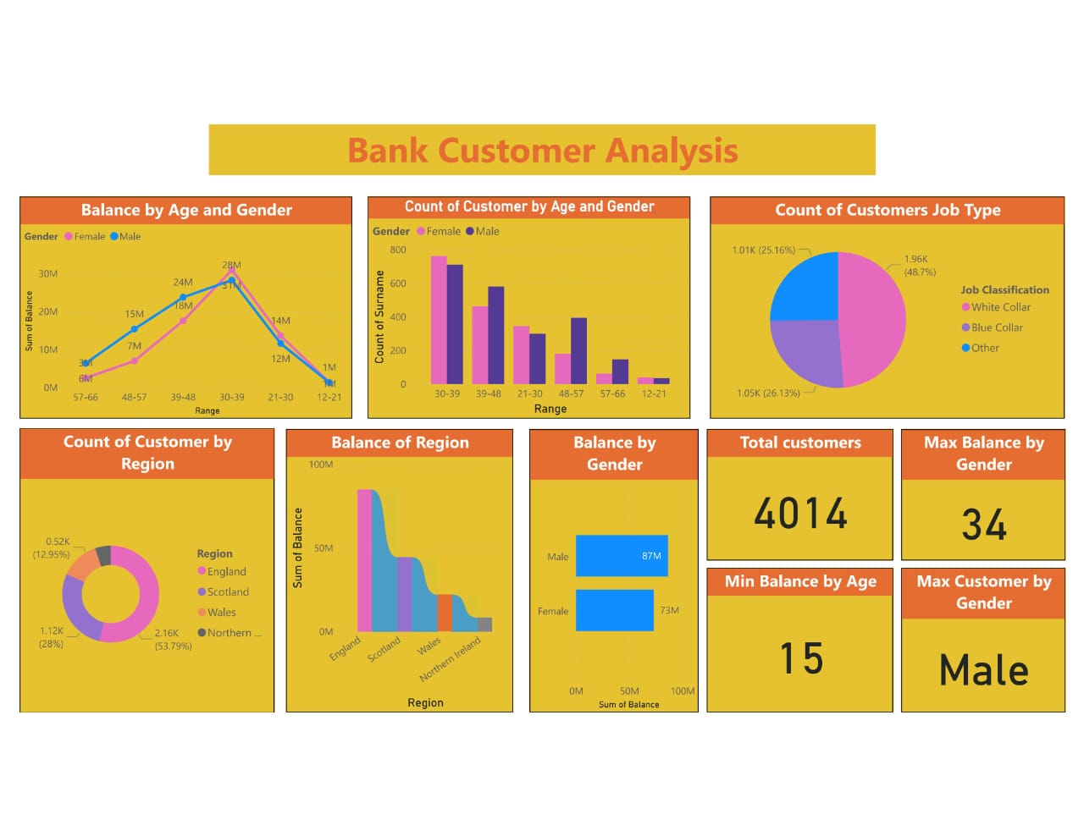

**CONCLUSION**

The project “Real-Time Analysis of Bank Customers” using PowerBI has successfully demonstrated the potential of data analytics in the banking sector. The real-time analysis of customer data has provided valuable insights into customer behavior, preferences, and trends, thereby facilitating informed decision-making. The interactive dashboards and reports have offered a comprehensive view of customer data, enabling the identification of patterns and correlations. This has not only improved the efficiency of data analysis but also enhanced the bank’s ability to provide personalized services to its customers. The project has also highlighted the importance of data visualization in making complex data more understandable and accessible. The use of PowerBI has made it possible to present data in a visually appealing and easy-to-understand format, thereby aiding in better decision-making.

**FUTURE SCOPE**

The future scope of this project is vast. With the advent of advanced analytics and machine learning, PowerBI can be leveraged to predict future trends based on historical data. Integrating these predictive analytics into the project could enable the bank to anticipate customer needs and proactively offer solutions. Furthermore, PowerBI’s capability to integrate with various data sources opens up the possibility of incorporating more diverse datasets for a more holistic view of customers. As data privacy and security become increasingly important, future iterations of this project should focus on implementing robust data governance strategies. This would ensure the secure handling of sensitive customer data while complying with data protection regulations. Additionally, the project could explore the integration of real-time data streams to provide even more timely and relevant insights. This could potentially transform the way banks interact with their customers, leading to improved customer satisfaction and loyalty.

**GITHUB LINK**

<https://github.com/Balakrishnaveni-PowerBI/Balakrishnaveni-PowerBI>